***This is a bonus Web chapter

CHAPTER 45

Web Services

Objectives

- To describe what a Web service is (§45.1).
- To create a Web service class (§45.2).
- To publish and test a Web service (§45.3).
- To create a Web service client reference (§45.4).
- To explain the role of WSDL (§45.4).
- To pass arguments of object type in a Web service (§45.5).
- To discover how a client communicates with a Web service (§45.5).
- To describe what SOAP requests and SOAP responses are (§45.5).
- To track a session in Web services (§45.6).
45.1 Introduction

<Side Remark: platform independent>
<Side Remark: language independent>
Web service is a technology that enables programs to communicate through HTTP on the Internet. Web services enable a program on one system to invoke a method in an object on another system. You can develop and use Web services using any languages on any platform. Web services are simple and easy to develop.

<Side Remark: SOAP>
<Side Remark: publishing Web services>
<Side Remark: consuming Web services>
Web services run on the Web using HTTP. There are several APIs for Web services. A popular standard is the Simple Object Access Protocol (SOAP), which is based on XML. The computer on which a Web service resides is referred to as a server. The server needs to make the service available to the client, known as publishing a Web service. Using a Web service from a client is known as consuming a Web service.

<Side Remark: proxy object>
A client interacts with a Web service through a proxy object. The proxy object facilitates the communication between the client and the Web service. The client passes arguments to invoke methods on the proxy object. The proxy object sends the request to the server and receives the result back from the server, as shown in Figure 45.1.

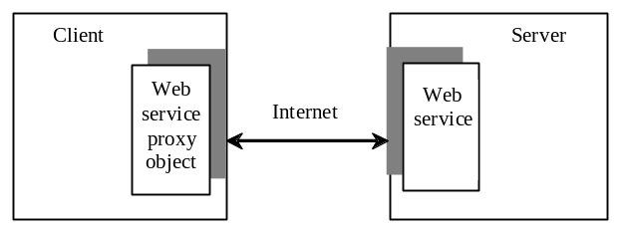

Figure 45.1
A proxy object serves as a facilitator between a client and a Web service.

45.2 Creating Web Services
<Side Remark: Web service tool>
There are many tools for creating Web services. This book demonstrates creating Web services using NetBeans.

<Side Remark: install GlashFish 3>
NOTE:
Apache Tomcat Server does not work well with Web services. To develop and deploy Web services using NetBeans, you need to install GlassFish 3. For information on how to install GlassFish 3 on NetBeans 7, see Supplement II.I.
***END NOTE

We now create a Web service for obtaining student scores. A Web service is a class that contains the methods for the client to invoke. Name the class ScoreService with a method named findScore(String name) that returns the score for a student.

<Side Remark: NetBeans Web project>
First you need to create a Web project using the following steps:

Choose File › New Project to display the New Project dialog box.
In the New Project dialog box, choose Java Web in the Categories pane and choose Web Application in the Projects pane. Click Next to display the New Web Application dialog box.
Enter WebServiceProject as the project name, specify the location where you want the project to be stored, and click Next to display the Server and Setting dialog.
Select GlassFish 3 as the server and Java EE 6 Web as the Java EE version. Click Finish to create the project.

<Side Remark: create Web service class>
Now you can create the ScoreService class in the project as follows:

Right-click the WebServiceProject in the Project pane to display a context menu. Choose New › Web Service to display the New Web Service dialog box.
Enter ScoreService in the Web Service Name field and enter chapter45 in the Package field. Click Finish to create ScoreService.
Complete the source code as shown in Listing 45.1.

Listing 45.1 ScoreService.java

<Side Remark line 4: import for @WebService>
<Side Remark line 5: import for @WebMethod>
<Side Remark line 7: define WebService>
<Side Remark line 19: define WebMethod>
package chapter45;

import java.util.HashMap;
import javax.jws.WebService; // For annotation @WebService
import javax.jws.WebMethod; // For annotation @WebMethod

@WebService(name = "ScoreService", serviceName = "ScoreWebService")
public class ScoreService {
// Stores scores in a map indexed by name
private HashMap<String, Double> scores =
new HashMap<String, Double>();

public ScoreService() {
scores.put("John", 90.5);
scores.put("Michael", 100.0);
scores.put("Michelle", 98.5);
}

@WebMethod(operationName = "findScore")
public double findScore(String name) {
Double d = scores.get(name);

if (d == null) {
System.out.println("Student " + name + " is not found ");
return -1;
}
else {
System.out.println("Student " + name + "\'s score is "
+ d.doubleValue());
return d.doubleValue();
}
}
}

<Side Remark: what is annotation?>
<Side Remark: boilerplate code>
Lines 4-5 import the annotations used in the program in lines 7 and 19. Annotation is a new feature in Java, which enables you to simplify coding. The compiler will automatically generate the code for the annotated directives. So, it frees the programmer from writing the detailed boilerplate code that could be generated mechanically. The annotation (line 7)

@WebService(name = "ScoreService", serviceName = "ScoreWebService")

tells the compiler that the class ScoreService is associated with the Web service named ScoreWebService.

The annotation (line 19)

@WebMethod(operationName = "findScore")

indicates that findScore is a method that can be invoked from a client.

The findScore method returns a score if the name is in the hash map. Otherwise, it returns -1.0.

You can manually type the code for the service, or create it from the Design tab, as shown in Figure 45.2.

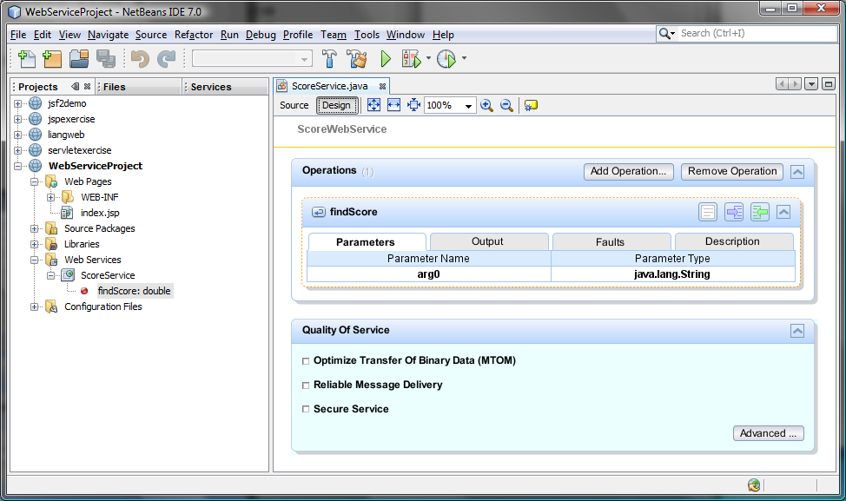
Figure 45.2
The services can also be created from the Design pane.

45.3 Deploying and Testing Web Services
<Side Remark: publishing Web services>
After a Web service is created, you need to deploy it for clients to use. Deploying Web services is also known as publishing Web services. To deploy it, right-click the WebServiceProject in the Project to display a context menu and choose Deploy. This command will first undeploy the service if it was deployed and then redeploy it.

Now you can test the Web service by entering the follow URL in a browser, as shown in Figure 45.3.

http://localhost:8080/WebServiceProject/ScoreWebService?Tester

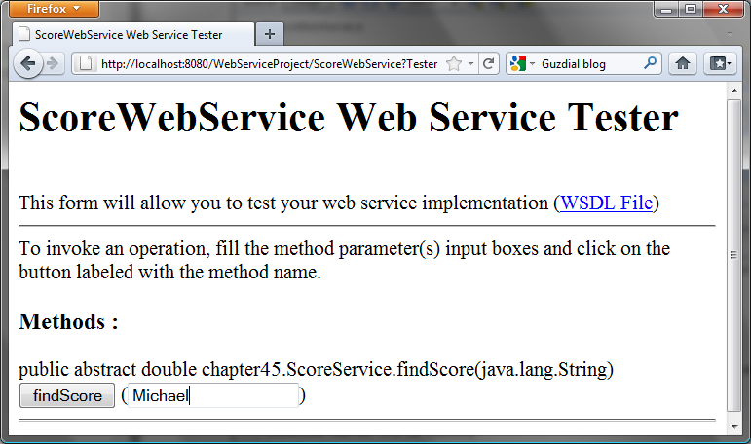

Figure 45.3
The test page enables you to test Web services.

Note that ScoreWebService is the name you specified in line 7 in Listing 45.1. This Web service has only one remote method named findScore. You can define an unlimited number of remote methods in a Web service class. If so, all these methods will be displayed in the test page.

To test the findScore method, enter Michael and click findScore. You will see that the method returns 100.0, as shown in Figure 45.4.

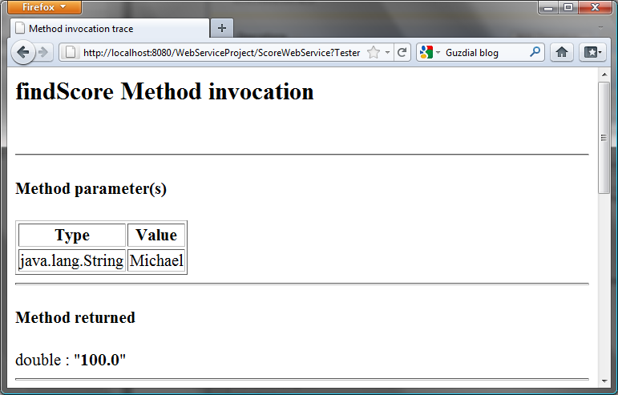

Figure 45.4
The method returns a test value.

<Side Remark: testing from another machine>
NOTE: If your computer is connected to the Internet, you can test Web services from another computer by entering the following URL:

http://host:8080/WebServiceProject/ScoreWebService?Tester

<Side Remark: ipconfig>
Where host is the host name or IP address of the server on which the Web service is running. On Windows, you can find your IP address by typing the command ipconfig.
***END NOTE

<Side Remark: Windows firewall>
NOTE: If you are running the server on Windows, the firewall may prevent remote clients from accessing the service. To enable it, do the following:

- In the Windows control panel, click Windows Firewall to display the Windows Firewall dialog box.
- In the Advanced tab, double-click Local Area Connection to display the Advanced Settings dialog box. Check Web Server(HTTP) to enable HTTP access to the server.
- Click OK to close the dialog box.
***END NOTE

45.4 Consuming Web Services
<Side Remark: consuming Web services>
After a Web service is published, you can write a client program to use it. A client can be any program (standalone application, applet, servlet/JSP/JSF application, or another Web service) and written in any language.

We will use NetBeans to create a Web service client. Our client is a Java applet with a main method, so you can also run it standalone. The applet simply lets the user enter a name and displays the score, as shown in Figure 45.5.

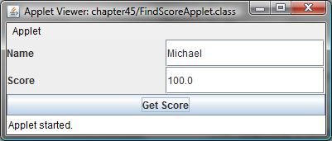

Figure 45.5
The applet client uses the Web service to find scores.

Let us create a project for the client. The project named ScoreWebServiceClientProject can be created as follows:

Choose File › New Project to display the New Project dialog box.
In the New Project dialog box, choose Java in the Categories pane and choose Java Application in the Projects pane. Click Next to display the New Java Application dialog box.
Enter ScoreWebServiceClientProject as the project name, specify the location where you want the project to be stored, and uncheck the Create Main Class check box. Click Finish to create the project.

<Side Remark: Web service reference>
You need to create a Web service reference to this project. The reference will enable you to create a proxy object to interact with the Web service. Here are the steps to create a Web service reference:

Right-click the ScoreWebServiceClientProject in the Project pane to display a context menu. Choose New › Web Service Client to display the New Web Service Client dialog box, as shown in Figure 45.6.

Check the WSDL URL radio button and enter
http://localhost:8080/WebServiceProject/ScoreWebService?WSDL
in the WSDL URL field.

Enter myWebservice in the package name field and choose JAX-WS as the JAX version. Click Finish to generate the Web service reference.

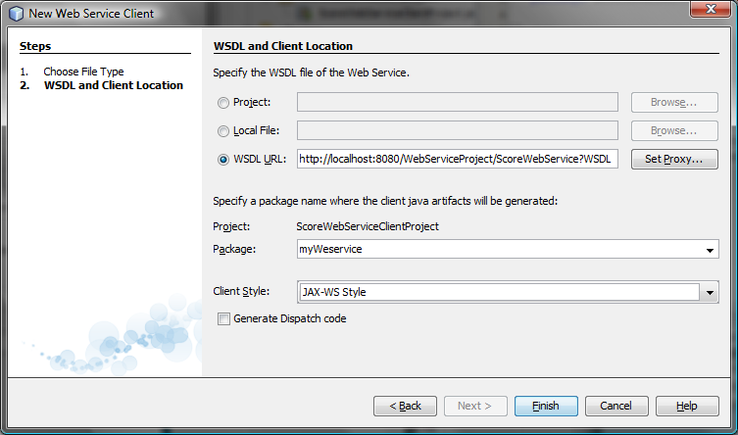

Figure 45.6
The New Web Service Client dialog box creates a Web service reference.

Now you will see ScoreWebService created in the Web Service References folder in the Projects tab. The IDE has generated many supporting files for the reference. You can view all the generated .java files from the Files tab in the project pane, as shown in Figure 45.7. These files will be used by the proxy object to interact with the Web service.

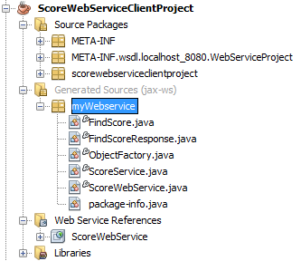

Figure 45.7
You can see the automatically generated boilerplate code for Web services in the Generated Sources folder in the client’s project.

<Side Remark: what is WSDL?>
NOTE: When you created a Web service reference, you entered a WSDL URL, as shown in Figure 45.6. This creates a .wsdl file. In this case, it is named ScoreWebService.wsdl under the Web Service References folder, as shown in Figure 45.8. So what is WSDL? WSDL stands for Web Service Description Language. A .wsdl file is an XML file that describes the available Web service to the client—i.e., the remote methods, their parameters and return value types, and so on.

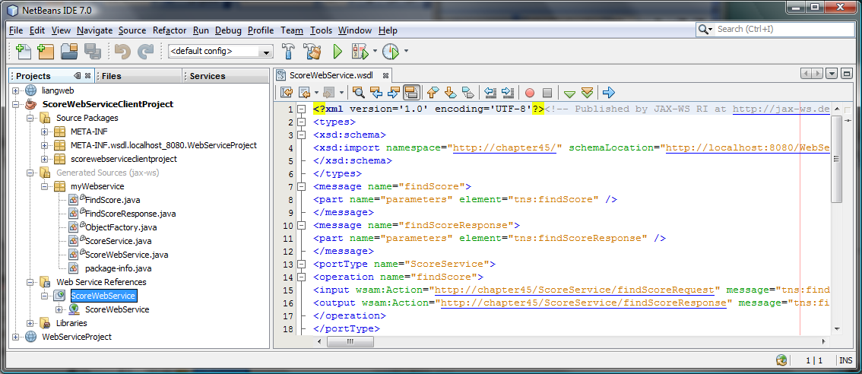

Figure 45.8
The .wsdl file describes Web services to clients.

<Side Remark: refresh reference>
NOTE: If the Web service is modified, you need to refresh the reference for the client. To do so, right-click the Web service node under Web Service References to display a context menu and choose Refresh Client.

Now you are ready to create an applet client for the Web service. Right-click the ScoreWebServiceClientProject node in the Project pane to display a context menu, and choose New › JApplet to create a Java applet named FindScoreApplet in package chapter45, as shown in Listing 45.2.

Listing 45.2 FindScoreApplet.java
<Side Remark line 11: create a service object>
<Side Remark line 12: create a proxy object>
<Side Remark line 39: invoke remote method>
<Side Remark line 51: main method omitted>

package chapter45;

import myWebservice.ScoreWebService;
import myWebservice.ScoreService;
import javax.swing.*;
import java.awt.*;
import java.awt.event.*;

public class FindScoreApplet extends JApplet {
// Declare a service object and a proxy object
private ScoreWebService scoreWebService = new ScoreWebService();
private ScoreService proxy = scoreWebService.getScoreServicePort();

private JButton jbtGetScore = new JButton("Get Score");
private JTextField jtfName = new JTextField();
private JTextField jtfScore = new JTextField();

public void init() {
JPanel jPanel1 = new JPanel();
jPanel1.setLayout(new GridLayout(2, 2));
jPanel1.add(new JLabel("Name"));
jPanel1.add(jtfName);
jPanel1.add(new JLabel("Score"));
jPanel1.add(jtfScore);

add(jbtGetScore, BorderLayout.SOUTH);
add(jPanel1, BorderLayout.CENTER);

jbtGetScore.addActionListener(new ActionListener() {
public void actionPerformed(ActionEvent evt) {
getScore();
}
});
}

private void getScore() {
try {
// Get student score
double score = proxy.findScore(jtfName.getText().trim());

// Display the result
if (score < 0)
jtfScore.setText("Not found");
else
jtfScore.setText(new Double(score).toString());
}
catch(Exception ex) {
ex.printStackTrace();
}
}
}

The program creates a Web service object (line 11) and creates a proxy object (line 12) to interact with the Web service.

To find a score for a student, the program invokes the remote method findScore on the proxy object (line 39).

45.5 Passing and Returning Arguments
<Side Remark: SOAP>
In the preceding example, a Web service client that you created invokes the findScore method with a string argument, and the Web service executes the method and returns a score as a double value. How does this work? It is the Simple Object Access Protocol (SOAP) that facilitates communications between the client and server.

<Side Remark: SOAP request>
<Side Remark: SOAP response>
SOAP is based on XML. The message between the client and server is described in XML. Figure 45.9 shows the SOAP request and SOAP response for the findScore method.

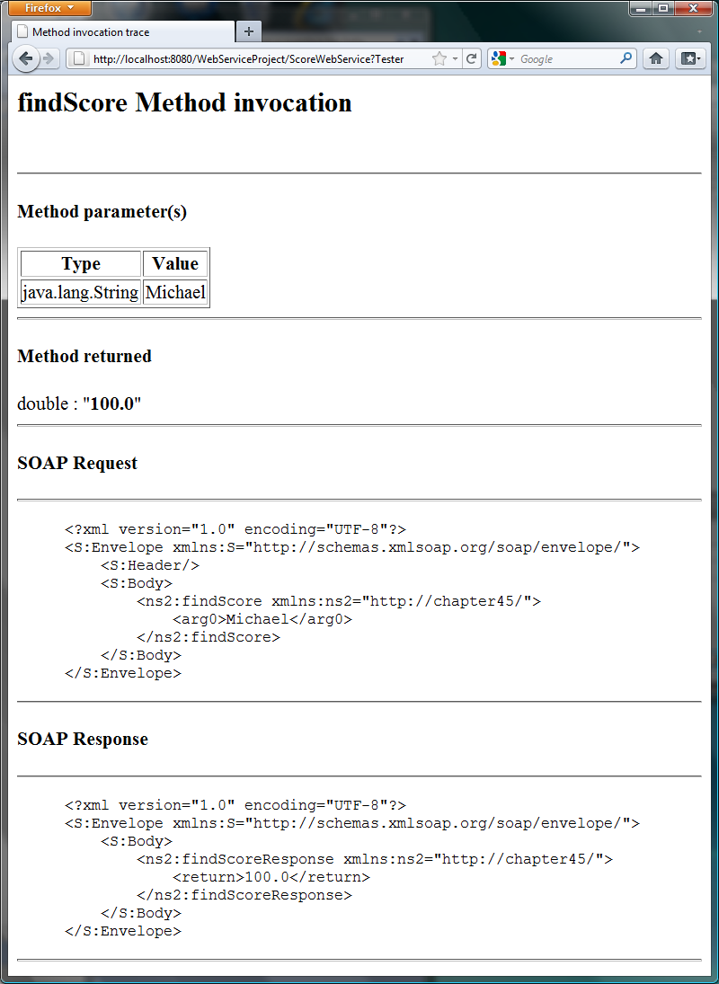

Figure 45.9
The client request and server response are described in XML.

When invoking the findScore method, a SOAP request is sent to the server. The request contains the information about the method and the argument. As shown in Figure 45.9, the XML text

<ns1:findScore>
<arg0>Michael</arg0>
</ns1:findScore>

specifies that the method findScore is called with argument Michael.

Upon receiving the SOAP request, the Web service parses it. After parsing it, the Web service invokes an appropriate method with specified arguments (if any) and sends the response back in a SOAP response. As shown in Figure 45.9, the XML text

<ns1:findScoreResponse>
<return>100.0</return>
</ns1:findScoreResponse>

specifies that the method returns 100.0.

The proxy object receives the SOAP response from the Web service and parses it. This process is illustrated in Figure 45.10.

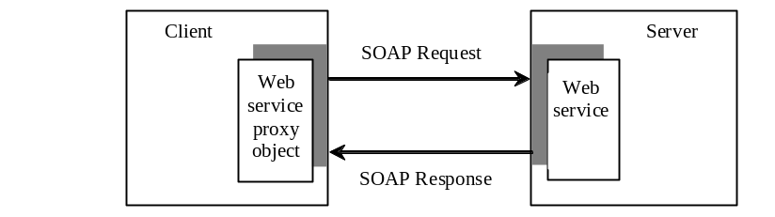

Figure 45.10
A proxy object sends SOAP requests and receives SOAP responses.

<Side Remark: XML serialization>
<Side Remark: XML deserialization>
Can you pass an argument of any type between a client and a Web service? No. SOAP supports only primitive types, wrapper types, arrays, String, Date, Time, List, and several other types. It also supports certain custom classes. An object that is sent to or from a server is serialized into XML. The process of serializing/deserializing objects, called XML serialization/deserialization, is performed automatically. For a custom class to be used with Web methods, the class must meet the following requirements:

<Side Remark: no-arg constructor>
The class must have a no-arg constructor.
<Side Remark: get and set methods>
Instance variables that should be serialized must have public get and set methods. The classes of these variables must be supported by SOAP.

To demonstrate how to pass an object argument of a custom class, Listing 45.3 defines a Web service class named AddressService with two remote methods:

getAddress(String firstName, String lastName) that returns an Address object for the specified firstName and lastName.
storeAddress(Address address) that stores a Student object to the database.

Address information is stored in a table named Address in the database. The Address class was defined in Listing 42.12, Address.java. An Address object can be passed to or returned from a remote method, since the Address class has a no-arg constructor with get and set methods for all its properties.

Here are the steps to create a Web service named AddressService and the Address class in the project.

Right-click the WebServiceProject node in the project pane to display a context menu. Choose New › Web Service to display the New Web Service dialog box.
In the Web Service Name field, enter AddressService. In the Package field, enter chapter45. Click Finish to create the service class.
Right-click the WebServiceProject node in the project pane to display a context menu. Choose New › Java Class to display the New Java Class dialog box.
In the Class Name field, enter Address. In the Package field, enter chapter42. Click Finish to create the class.

The Address class is the same as shown in Listing 42.12. Complete the AddressService class as shown in Listing 45.3.

Listing 45.3 AddressService.java
<Side Remark line 8: define service name>
<Side Remark line 12: prepared statement>
<Side Remark line 15: prepared statement>
<Side Remark line 18: initialize database>
<Side Remark line 21: define remote method>
<Side Remark line 22: getAddress>
<Side Remark line 49: define remote method>
<Side Remark line 50: storeAddress>
<Side Remark line 68: initialize database>

package chapter45;

import chapter42.Address;
import java.sql.*;
import javax.jws.WebMethod;
import javax.jws.WebService;

@WebService(name = "AddressService",
serviceName = "AddressWebService")
public class AddressService {
// statement1 for retrieving an address and statement2 for storing
private PreparedStatement statement1;

// statement2 for storing an address
private PreparedStatement statement2;

public AddressService() {
initializeJdbc();
}

@WebMethod(operationName = "getAddress")
public Address getAddress(String firstName, String lastName) {
try {
statement1.setString(1, firstName);
statement1.setString(2, lastName);
ResultSet resultSet = statement1.executeQuery();

if (resultSet.next()) {
Address address = new Address();
address.setFirstName(resultSet.getString("firstName"));
address.setLastName(resultSet.getString("lastName"));
address.setMi(resultSet.getString("mi"));
address.setTelephone(resultSet.getString("telephone"));
address.setFirstName(resultSet.getString("email"));
address.setCity(resultSet.getString("telephone"));
address.setState(resultSet.getString("state"));
address.setZip(resultSet.getString("zip"));
return address;
}
else
return null;
} catch (SQLException ex) {
ex.printStackTrace();
}

return null;
}

@WebMethod(operationName = "storeAddress")
public void storeAddress(Address address) {
try {
statement2.setString(1, address.getLastName());
statement2.setString(2, address.getFirstName());
statement2.setString(3, address.getMi());
statement2.setString(4, address.getTelephone());
statement2.setString(5, address.getEmail());
statement2.setString(6, address.getStreet());
statement2.setString(7, address.getCity());
statement2.setString(8, address.getState());
statement2.setString(9, address.getZip());
statement2.executeUpdate();
} catch (SQLException ex) {
ex.printStackTrace();
}
}

/** Initialize database connection */
public void initializeJdbc() {
try {
Class.forName("com.mysql.jdbc.Driver");

// Connect to the sample database
Connection connection = DriverManager.getConnection(
"jdbc:mysql://localhost/javabook", "scott", "tiger");

statement1 = connection.prepareStatement(
"select * from Address where firstName = ? and lastName = ?");
statement2 = connection.prepareStatement(
"insert into Address " +
"(lastName, firstName, mi, telephone, email, street, city, "
+ "state, zip) values (?, ?, ?, ?, ?, ?, ?, ?, ?)");
} catch (Exception ex) {
ex.printStackTrace();
}
}
}

The new Web service is named AddressWebService (line 9) for the AddressService class.

When the service is deployed, the constructor (lines 17-19) of AddressWebService is invoked to initialize a database connection and create prepared statement1 and statement2 (lines 68-85).

The findAddress method searches the address in the Address table for the specified firstName and lastName. If found, the address information is returned in an Address object (lines 29-38). Otherwise, the method returns null (line 41).

The storeAddress method stores the address information from the Address object into the database (lines 52-61).

NOTE:
<Side Remark: database driver>
Don’t forget that you have to add the MySQL library to the WebServiceProject for this example to run.

Before you can use the service, deploy it. Right-click the WebServiceProject node in the Project to display a context menu and choose Deploy.

Now you are ready to develop a Web client that uses the AddressWebService. The client is a JSP program, as shown in Figure 45.11. The program has two functions. First, the user can enter the last name and first name and click the Search button to search for a record, as shown in Figure 45.12. Second, the user can enter the complete address information and click the Store button to store the information to the database, as shown in Figure 45.13.

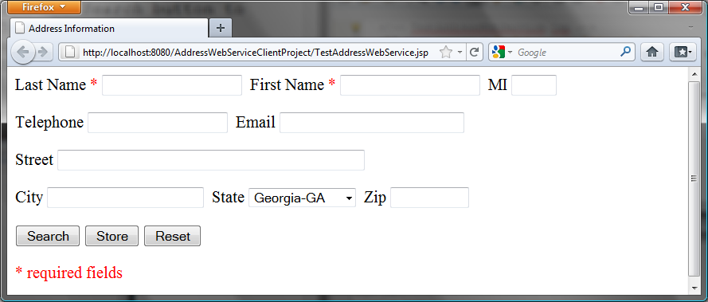

Figure 45.11
The TestAddressWebService page allows the user to search and store addresses.

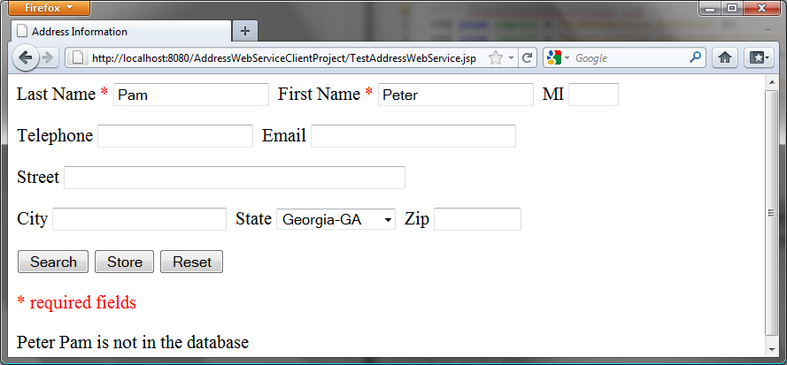

Figure 45.12
The Search button finds and displays an address.

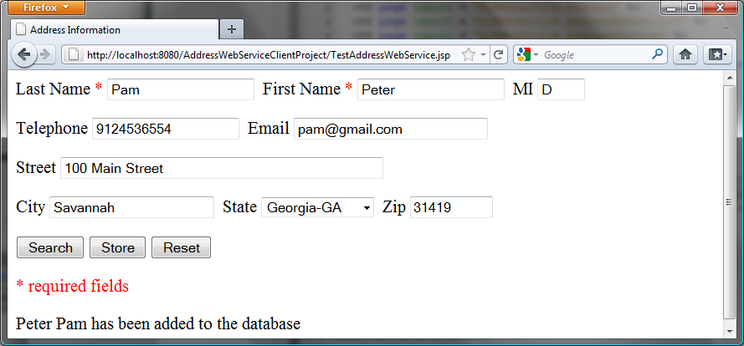

Figure 45.13
The Store button stores the address to the database.

Let us create a project for the client. The project named AddressWebServiceClientProject can be created as follows:

Choose File › New Project to display the New Web Application dialog box.
In the New Web Application dialog box, choose Java Web in the Categories pane and choose Web Application in the Projects pane. Click Next to display the Name and Location dialog box.
Enter AddressWebServiceClientProject as the project name, specify the location where you want the project to be stored, and uncheck the Set as Main Project check box. Click Next to display the Server and Settings dialog box.
Choose GlassFish Server 3 in the Server field, and Java EE 6 Web as in the Java EE Version field, and click Finish to create the project.

<Side Remark: Web service reference>
You need to create a Web service reference to this project. The reference will enable you to create a proxy object to interact with the Web service. Here are the steps to create a Web service reference:

Right-click the AddressWebServiceClientProject node in the Project pane to display a context menu. Choose New › Web Service Client to display the New Web Service Client dialog box.
Check the WSDL URL radio button and enter

http://localhost:8080/WebServiceProject/AddressWebService?WSDL

in the WSDL URL field.

3. Enter myWebservice in the package name field and choose JAX-WS as the JAX version. Click Finish to generate the Web service reference.

Now a reference to AddressWebService is created. Note that this process also copies Address.java to the client project, as shown in Figure 45.14.

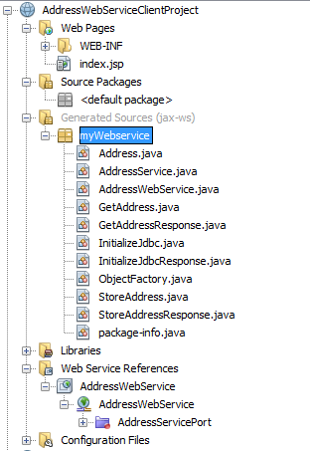

Figure 45.14
The Address.java is automatically copied to the Web service client reference package.

Create a JSP named TestAddressWebService in the AddressWebServiceClientProject project, as shown in Listing 45.4.

Listing 45.4 TestAddressWebService.jsp
<Side Remark line 2: import Address>
<Side Remark line 3: import AddressWebServices>
<Side Remark line 4: import AddressServices>
<Side Remark line 14: invoke the same page>
<Side Remark line 82: create Web service>
<Side Remark line 83: get proxy object>
<Side Remark line 85: process Store button>
<Side Remark line 86: invoke remote method>
<Side Remark line 90: process Search button>
<Side Remark line 91: invoke remote method>

<!-- TestAddressWebService.jsp -->
<%@ page import = "myWebservice.Address" %>
<%@ page import = "myWebservice.AddressWebService" %>
<%@ page import = "myWebservice.AddressService" %>
<jsp:useBean id = "addressId"
class = "myWebservice.Address" scope = "session"></jsp:useBean>
<jsp:setProperty name = "addressId" property = "*" />

<html>
<head>
<title>Address Information</title>
</head>
<body>
<form method = "post" action = "TestAddressWebService.jsp">
Last Name <font color = "#FF0000">*</font>
<input type = "text" name = "lastName"
<%if (addressId.getLastName() != null) {
out.print("value = \"" + addressId.getLastName() + "\"");}%>
size = "20" />&nbsp;

First Name <font color = "#FF0000">*</font>
<input type = "text" name = "firstName"
<%if (addressId.getFirstName() != null) {
out.print("value = \"" + addressId.getFirstName() + "\"");}%>
size = "20" />&nbsp;

MI
<input type = "text" name = "mi"
<%if (addressId.getMi() != null) {
out.print("value = \"" + addressId.getMi() + "\" "); } %>
size = "3" />&nbsp;

<p>Telephone
<input type = "text" name = "telephone"
<%if (addressId.getTelephone() != null) {
out.print("value = \"" + addressId.getTelephone() + "\" ");}%>
size = "20" />&nbsp;

Email
<input type = "text" name = "email"
<%if (addressId.getEmail() != null) {
out.print("value = \"" + addressId.getEmail() + "\" ");}%>
size = "28" />&nbsp;
</p>

<p>Street
<input type = "text" name = "street"
<%if (addressId.getStreet() != null) {
out.print("value = \"" + addressId.getStreet() + "\" ");}%>
size = "50" />&nbsp;
</p>

<p>City
<input type = "text" name = "city"
<%if (addressId.getCity() != null) {
out.print("value = \"" + addressId.getCity() + "\" ");}%>
size = "23" />&nbsp;

State
<select size = "1" name = "state">
<option value = "GA">Georgia-GA</option>
<option value = "OK">Oklahoma-OK</option>
<option value = "IN">Indiana-IN</option>
</select>&nbsp;

Zip
<input type = "text" name = "zip"
<%if (addressId.getZip() != null) {
out.print("value = \"" + addressId.getZip() + "\" "); } %>
size = "9" />&nbsp;
</p>

<p><input type = "submit" name = "Submit" value = "Search">
<input type = "submit" name = "Submit" value = "Store">
<input type = "reset" value = "Reset">
</p>
</form>
<p><font color = "#FF0000">* required fields</font></p>

<%
if (request.getParameter("Submit") != null) {
AddressWebService addressWebService = new AddressWebService();
AddressService proxy = addressWebService.getAddressServicePort();

if (request.getParameter("Submit").equals("Store")) {
proxy.storeAddress(addressId);
out.println(addressId.getFirstName() + " " +
addressId.getLastName() + " has been added to the database");
}
else if (request.getParameter("Submit").equals("Search")) {
Address address = proxy.getAddress(addressId.getFirstName(),
addressId.getLastName());
if (address == null)
out.print(addressId.getFirstName() + " " +
addressId.getLastName() + " is not in the database");
else
addressId = address;
}
}
%>
</body>
</html>

Lines 2-4 import the classes for the JSP page. The Address class (line 2) was created in the WebServiceProject and was automatically copied to the AddressWebServiceClientProjec project when a Web service reference for AddressWebService was created. A JavaBeans object for Address was created and associated with input parameters in lines 5-7.

The UI interface was laid in the form (lines 14-77). The action for the two buttons Search and Store invokes the same page TestAddressWebService.jsp (line 14).

When a button is clicked, a proxy object for AddressWebService is obtained (lines 82-83). For the Store button, the proxy object invokes the storeAddress method to add an address to the database (line 86). For the Search button, the proxy object invokes the getAddress method to return an address (lines 91-92). If no address is found for the specified first and last names, the returned address is null (line 93).

45.6 Web Service Session Tracking
<Side Remark: HttpSession>
§42.8.3, “Session Tracking Using the Servlet API,” introduced session tracking for servlets using the javax.servlet.http.HttpSession interface. You can use HttpSession to implement session tracking for Web services. To demonstrate this, consider an example that generates random True/False questions for the client and grades the answers on these questions for the client.

The Web client consists of two JSP pages: DisplayQuiz.jsp and GradeQuiz.jsp. The DisplayQuiz page invokes the service method
getQuestion() to display the questions, as shown in Figure 45.15. When you click the Submit button, the program invokes the service method gradeQuiz to grade the answers. The result is displayed in the GradeQuiz page, as shown in Figure 45.16.

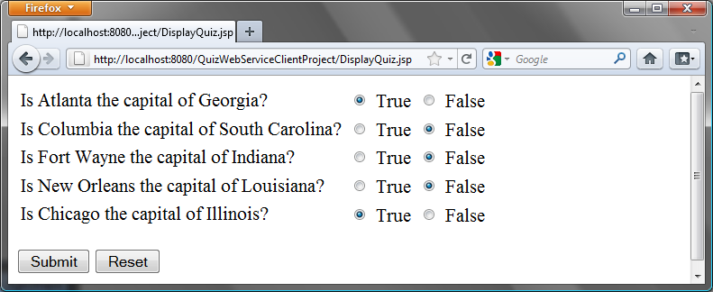
Figure 45.15
The Submit button submits the answers for grading.

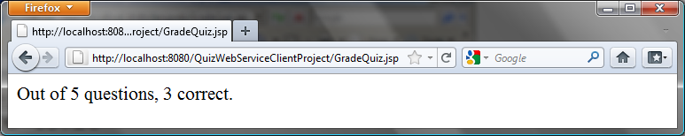
Figure 45.16
The answers are graded and displayed.

Why is session tracking needed for this project? Each time a client displays a quiz, it creates a randomly reorder the quiz for the client. Each client gets a different quiz every time the DisplayQuiz page is refreshed. When the client submits the answer, the Web service checks the answer against the previously generated quiz. So the quiz has to be stored in the session.

For convenience, let us create the Web service class named QuizService in the WebServiceProject in package chapter45. Listing 45.5 gives the program.

Listing 45.5 QuizService.java
<Side Remark line 9: enable session tracking>
<Side Remark line 10: define service name>
<Side Remark line 12: quiz>
<Side Remark line 16: initialize quiz>
<Side Remark line 28: shuffle>
<Side Remark line 31: define service method>
<Side Remark line 32: getQuestions>
<Side Remark line 42: define service method>
<Side Remark line 43: gradeQuiz>
<Side Remark line 46: check answers>

package chapter45;

import javax.jws.WebMethod;
import javax.jws.WebService;
import java.util.List;
import java.util.ArrayList;
import com.sun.xml.ws.developer.servlet.HttpSessionScope;

@HttpSessionScope
@WebService(name = "QuizService", serviceName = "QuizWebService")
public class QuizService {
private ArrayList<Object[]> quiz = new ArrayList<Object[]>();

public QuizService() {
// Initialize questions and answers
quiz.add(new Object[]{
"Is Atlanta the capital of Georgia?", true});
quiz.add(new Object[]{
"Is Columbia the capital of South Carolina?", true});
quiz.add(new Object[]{
"Is Fort Wayne the capital of Indiana?", false});
quiz.add(new Object[]{
"Is New Orleans the capital of Louisiana?", false});
quiz.add(new Object[]{
"Is Chicago the capital of Illinois?", false});

// Shuffle to generate a random quiz for a client
java.util.Collections.shuffle(quiz);
}

@WebMethod(operationName = "getQuestions")
public java.util.List<String> getQuestions() {
// Extract questions from quiz
List<String> questions = new ArrayList<String>();
for (int i = 0; i < quiz.size(); i++) {
questions.add((String)(quiz.get(i)[0]));
}

return questions; // Return questions in the quiz
}

@WebMethod(operationName = "gradeQuiz")
public List<Boolean> gradeQuiz(List<Boolean> answers) {
List<Boolean> result = new ArrayList<Boolean>();
for (int i = 0; i < quiz.size(); i++)
result.add(quiz.get(i)[1] == answers.get(i));

return result;
}
}

The Web service class named QuizService contains two methods getQuestions and gradeQuiz. The new Web service is named QuizWebService (line 10).

The annotation @HttpSessionScope (line 9) is new in JAX-WS 2.2, which enables the Web service automatically maintains a separate instance for each client session. To use this annotation, you have add JAX-WS 2.2 into your project’s library. This can be done by clicking the Library node in the project and select Add Library.

<Side Remark: creating a quiz>
Assume that five True/False questions are available from the service. The quiz is stored in an ArrayList (lines 16-25).
Each element in the list is an array with two values. The first value is a string that describes the question and the second is a Boolean value indicating whether the answer should be true or false.

<Side Remark: randomly shuffling>
A new quiz is generated in the constructor and the quiz is shuffled using the shuffle method in the Collections class (line 28).

<Side Remark: getQuestions>
The getQuestions method (lines 31-40) returns questions in a list. The questions are extracted from the quiz (lines 34-37) and are returned (line 39).

<Side Remark: gradeQuiz>
The gradeQuiz method (lines 42-49) checks the answers from the client with the answers in the quiz. The client’s answers are compared with the key, and the result of the grading is stored in a list. Each element in the list is a boolean value that indicates whether the answer is correct or incorrect (lines 44-46).

<Side Remark: create Web service client>
After creating and publishing the Web service, let us create a project for the client. The project named QuizWebServiceClientProject can be created as follows:

Choose File › New Project to display the New Web Application dialog box.
In the New Web Application dialog box, choose Java Web in the Categories pane and choose Web Application in the Projects pane. Click Next to display the Name and Location dialog box.
Enter QuizWebServiceClientProject as the project name, specify the location where you want the project to be stored, and uncheck the Set as Main Project check box. Click Next to display the Server and Settings dialog box.
Choose GlassFish Server 3 in the Server field, and Java EE 6 Web as in the Java EE Version field, and click Finish to create the project.

<Side Remark: Web service reference>
To use QuizWebService, you need to create a Web service client as follows:

Right-click the QuizWebServiceClientProject project in the Project pane to display a context menu. Choose New › Web Service Client to display the New Web Service Client dialog box.
Check the WSDL URL radio button and enter

http://localhost:8080/WebServiceProject/QuizWebService?WSDL

in the WSDL URL field.

Enter myWebservice in the Package field.

Click Finish to create the reference for QuizWebService.

Now a reference to QuizWebService is created. You can create a proxy object to access the remote methods in QuizService. Listings 45.6 and 45.7 show DisplayQuiz.jsp and GradeQuiz.jsp.

Listing 45.6 DisplayQuiz.jsp
<Side Remark line 2: import QuizWebService>
<Side Remark line 3: import QuizServices>
<Side Remark line 4: create QuizWebServices>
<Side Remark line 11: get proxy object>
<Side Remark line 12: get questions>
<Side Remark line 20: display questions>

<!-- DisplayQuiz.jsp -->
<%@ page import = "myWebservice.QuizWebService" %>
<%@ page import = "myWebservice.QuizService" %>
<jsp:useBean id = "quizWebService" scope = "session"
class = "myWebservice.QuizWebService">
</jsp:useBean>

<html>
<body>
<%
QuizService proxy = quizWebService.getQuizServicePort();
java.util.List<String> questions =
(java.util.ArrayList<String>)(proxy.getQuestions());
%>
<form method = "post" action = "GradeQuiz.jsp">
<table>
<% for (int i = 0; i < questions.size(); i++) {%>
<tr>
<td>
<label><%= questions.get(i) %></label>
</td>
<td>
<input type = "radio" name = <%= "question" + i%>
value = "True" /> True
</td>
<td>
<input type = "radio" name = <%= "question" + i%>
value = "False" /> False
</td>
</tr>
<%}%>
</table>
<p><input type = "submit" name = "Submit" value = "Submit">
<input type = "reset" value = "Reset">
</p>
</form>
</body>
</html>

This page generates a quiz by invoking the getQuestions() in lines 12-13. The questions are displayed in a table with radio buttons (lines 16-32). Clicking Submit invokes GradeQuiz.jsp.

Listing 45.7 GradeQuiz.jsp
<Side Remark line 2: import QuizWebService>
<Side Remark line 3: import QuizServices>
<Side Remark line 4: create QuizWebServices>
<Side Remark line 11: get proxy object>
<Side Remark line 12: get questions>
<Side Remark line 15: get client’s answers>
<Side Remark line 25: grade answers>
<Side Remark line 28: analyze result>

<!-- GradeQuiz.jsp -->
<%@ page import = "myWebservice.QuizWebService" %>
<%@ page import = "myWebservice.QuizService" %>
<jsp:useBean id = "quizWebService" scope = "session"
class = "myWebservice.QuizWebService">
</jsp:useBean>

<html>
<body>
<%
QuizService proxy = quizWebService.getQuizServicePort();
java.util.List<String> quiz = proxy.getQuestions();

// Get the answer from the DisplayQuiz page
java.util.List<Boolean> answers = new java.util.ArrayList<Boolean>();
for (int i = 0; i < quiz.size(); i++) {
String trueOrFalse = request.getParameter("question" + i);
if (trueOrFalse.equals("True"))
answers.add(true); // Answered true
else if (trueOrFalse.equals("False"))
answers.add(false); // Answered false
}

// Grade answers
java.util.List<Boolean> result = proxy.gradeQuiz(answers);

// Find the correct count
int correctCount = 0;
for (int i = 0; i < result.size(); i++) {
if (result.get(i))
correctCount++;
}
%>

Out of <%= result.size() %> questions, <%= correctCount %> correct.
</body>
</html>

This page collects the answers passed from the HTML form from the DisplayQuiz page (lines 15-21), invokes the gradeQuiz method to grade the quiz (line 25), finds the correct count (lines 28-31), and displays the result (line 35).

NOTE:
You need to answer all five questions before clicking the Submit button. A runtime error will occur if a radio button is not checked. You can fix this problem in Exercise 45.5.

Key Terms

- @WebService
- @WebMethod
- consuming a Web service
- proxy object
- publishing a Web service
- Web service
- Web service client reference
- WSDL

Chapter Summary

- Web services enable a Java program on one system to invoke a method in an object on another system.
- Web services are platform and language independent. You can develop and use Web services using any language.
- Web services run on the Web using HTTP. SOAP is a popular protocol for implementing Web services.
- The server needs to make the service available to the client, known as publishing a Web service. Using a Web service from a client is known as consuming a Web service.
- A client interacts with a Web service through a proxy object. The proxy object facilitates the communication between the client and the Web service.
- You need to use Java annotation @WebService to annotate a Web service and use annotation @WebMethod to annotate a remote method.
- A Web service class may have an unlimited number of remote methods.
- After a Web service is published, you can write a client program to use it. You have to first create a Web client reference. From the reference, you create a proxy object for facilitating communication between a server and a client.
- WSDL stands for Web Service Description Language. A .wsdl file is an XML file that describes the available Web service to the client—i.e., the remote methods, their parameters and return value types, and so on.
- The message between the client and server is described in XML. A SOAP request describes the information that is sent to the Web service and a SOAP response describes the information that is received from the Web service.
- The objects passed between client and Web service are serialized in XML. Not all object types are supported by SOAP.
- You can track sessions in Web services using the HttpSession in the same way as in servlets.

Test Questions
Do the test questions for this chapter online at www.cs.armstrong.edu/liang/intro9e/test.html.

Review Questions
Section 45.1
45.1 What is a Web service?

45.2 Can you invoke a Web service from a language other than Java?

45.3 Do Web services support callback? That is, can a Web service call a method from a client’s program?

45.4 What is SOAP? What is it to publish a Web service? What is it to consume a Web service? What is the role of a proxy object?

Sections 45.2-45.6
45.5 What is the annotation to specify a Web service? What is the annotation to specify a Web method?

45.6 How do you deploy a Web service in NetBeans?

45.7 Can you test a Web service from a client?
45.8 How do you create a Web service reference for a client?

45.9 What is WSDL? What is SOAP? What is a SOAP request? What is a SOAP response?

45.10 Can you pass primitive type arguments to a remote method? Can you pass any object type to a remote method? Can you pass an argument of a custom type to a remote method?

45.11 How do you obtain an HttpSession object for tracking a Web session?

45.12 Can you create two Web service references in one package in the same project in NetBeans?

45.13 What happens if you don’t clone the quiz in lines 40-41 in Listing 45.5, QuizService.java?

Programming Exercises

45.1*
(Get a score from a database table) Suppose that the scores are stored in the Scores table. The table was created as follows:

create table Scores (name varchar(20),
score number, permission boolean);

insert into Scores values ('John', 90.5, 1);
insert into Scores values ('Michael', 100, 1);
insert into Scores values ('Michelle', 100, 0);

Revise the findScore method in Listing 45.1, ScoreService.java, to obtain a score for the specified name. Note that your program does not need the permission column; ignore it. The next exercise will need the permission column.

45.2*
(Permission to find scores) Revise the preceding exercise so that the findScore method returns -1 if permission is false. Add a another method named getPermission(String name) that returns 1, 0, or -1. The method returns 1 if the student is in the Scores table and permission is true, 0 if the student is in the Scores table and permission is false, and -1 if the student is not in the Scores table.

45.3*
(Compute loan) You can compute a loan payment for a loan with the specified amount, number of years, and annual interest rate. Write a Web service with two remote methods for computing monthly payment and total payment. Write a client program that prompts the user to enter loan amount, number of years, and annual interest rate.

45.4*
(Web service visit count) Write a Web service with a method named getCount() that returns the number of the times this method has been invoked from a client. Use a session to store the count variable.

45.5*
(Quiz) The user needs to answer all five questions before clicking the Submit button in the Quiz application in §45.6, Web Service Session Tracking. A runtime error will occur if a radio button is not checked. Fix this problem.

